TECHNICAL PROJECT LOGBOOK & PROGRESS REPORT

Student Details
Student Name: Brian kibet
Admission Number: BIT/20221/93373
Course/Class: Bachelor of Science in Information Technology
Unit Code: BIT4107
Unit Name: Mobile Application Development
Lecturer Name: Michael Nyoro

Project Details
Project Title: SETBOOK HUB
Selected Technologies: Kotlin
Jetpack Compose
Android Studio
SQLite
GitHub Link:

Week 1: Local Environment Setup
Figure 1.1: Installation of visual studio code
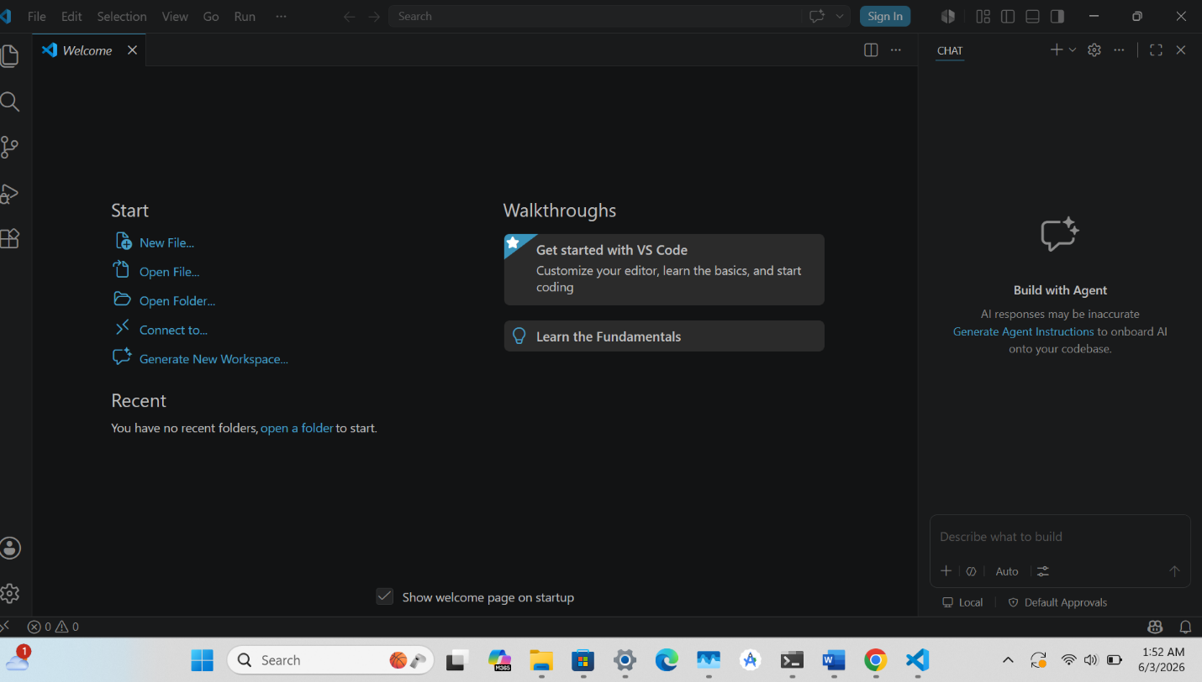
WEEK 1 REFLECTION: Installing Visual Studio Code was a valuable learning experience that enhanced my software development environment. I learned how to download, install, and configure the application successfully. The process improved my understanding of development tools and their importance in coding, debugging, and managing projects efficiently and effectively.

Week 2: Screen Display
Figure 2.1: Testing of "UserName"
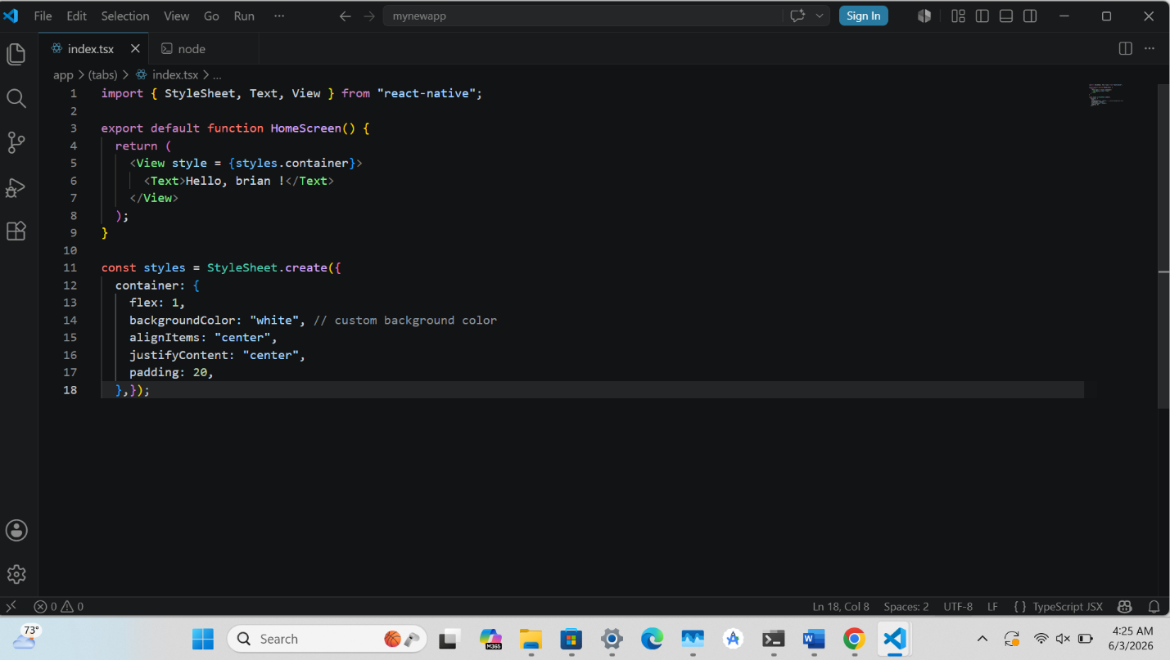
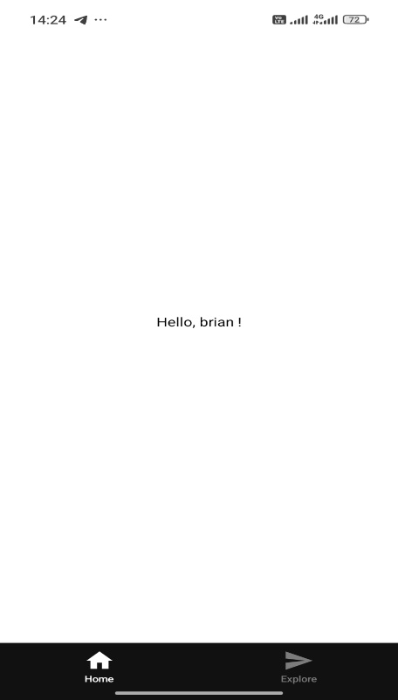

WEEK 2 REFLECTION: Through this practical, I learned the fundamentals of mobile application development using Android Studio and Kotlin. I gained experience in creating projects, understanding the development environment, and building a simple Hello World application. The exercise improved my confidence in mobile app development and prepared me for more advanced tasks.

Week 3: Wireframes and GUI Design
Figure 3.1: Screen splash

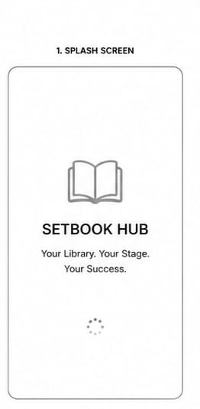

Figure 3.2: Home dashboard screen

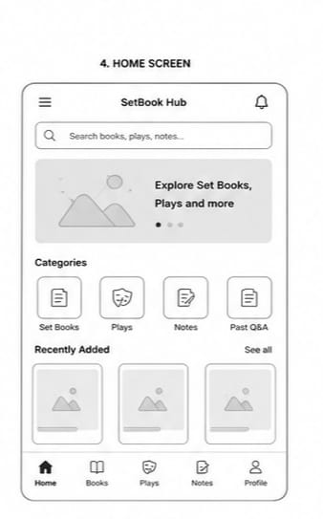

Figure 3.3: Place book list

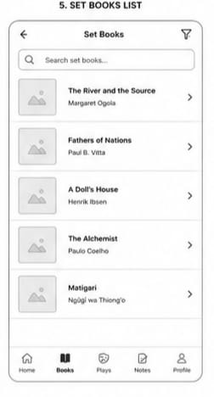

Figure 3.4: Place details

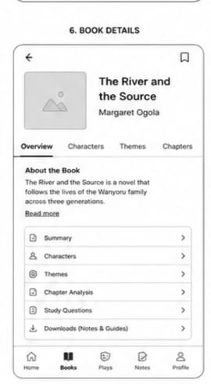

Figure 3.5: About screen

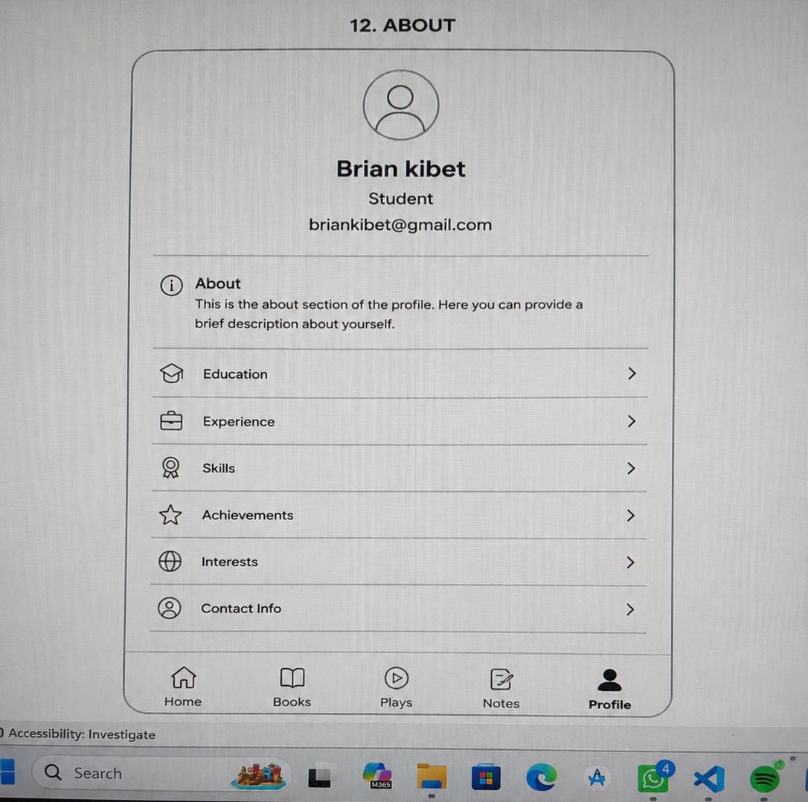

WEEK 3 REFLECTION: The wireframes provided a clear visual blueprint for the SetBook Hub application. They helped define the user journey, screen layouts, navigation flow, and core features before development. Creating the wireframes improved understanding of user requirements, identified design improvements early, and ensured consistency across all screens, reducing development errors and rework.

WEEK 4 USER INTERACTION
FIGURE 3.5 logins
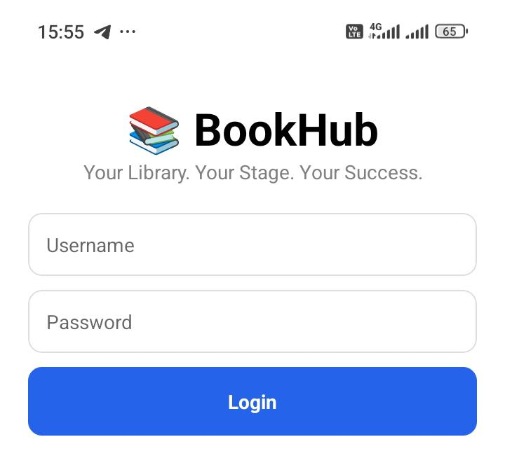
User Authentication Gatekeeping: By introducing a login screen, you are transitioning your application from a public viewer to a personalized experience. This is the first step toward handling user sessions, access tokens and user-specific data storage.

FIGURE3.6 REGISTRATION
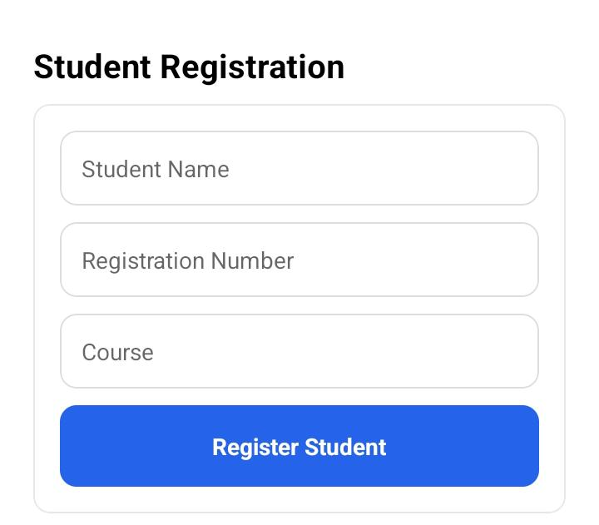

Week reflection: developed the BookHub login page, Student Name, Registration Number, Course and home screen using React Native. I designed the user interface, added login validation, and created categories such as Set Books, Plays, Notes, and Past Papers. This improved my skills in mobile app development and UI design.

WEEK 5 DATA MANAGEMENT
FIGURE 3.7
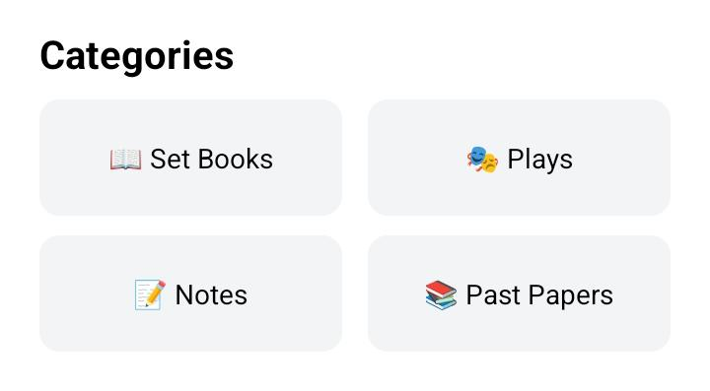

FIGURE 3.8 REGISTRED STUDENTS DATA
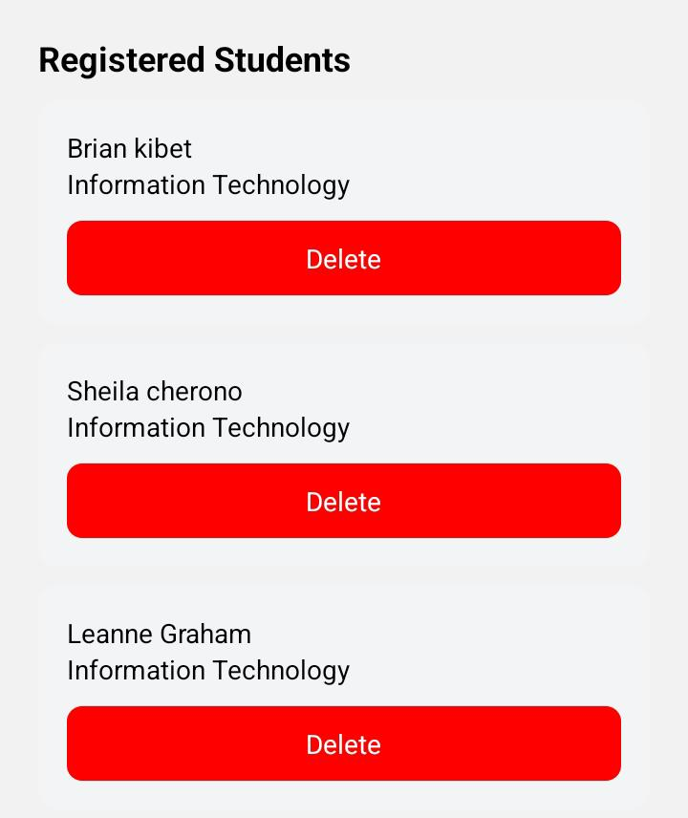
Week reflection: I enhanced the BookHub application by adding more features,Book Search, Profile, Reports, Favorites, and Downloads. I also improved the app layout and navigation, gaining more experience in React Native and project organization.

WEEK 6: NETWORKING AND APIs
Figure 3.9 Books fetched from API
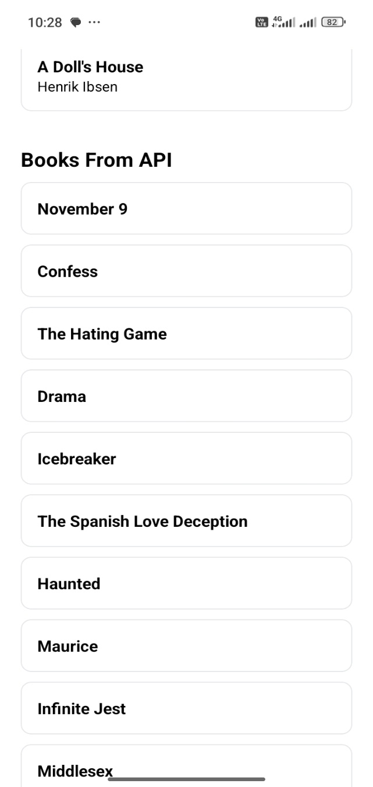

FIGURE 4.0 ERROR HANDLING.
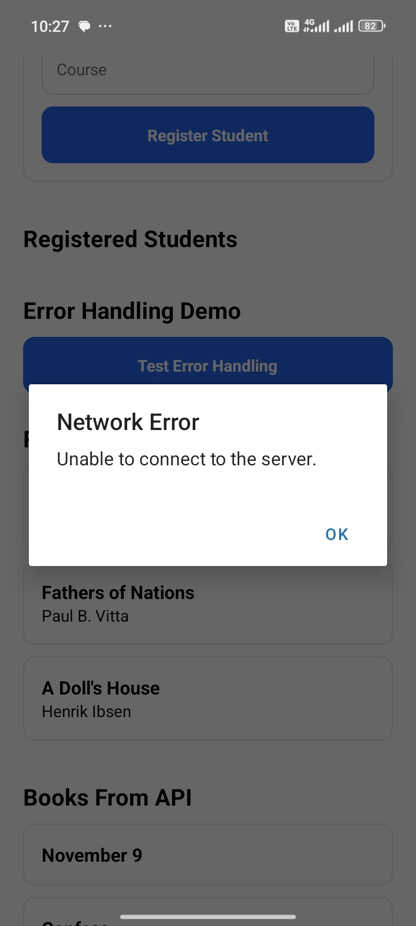

WEEK 6 :REFLECTION
Successful Asynchronous Data Fetching Error handling: I have successfully transitioned from building static layouts to connecting an app to the live internet. Fetching external data requires managing network requests, background threads, and parsing JSON data into UI

